Press Information
May 2018

Kaprun’s K-onnection generational project picks up speed
New era on the Maiskogel in Kaprun
Opening of MK Maiskogelbahn and Kaprun Center scheduled for December 2018

In April, construction got underway to create a lift connection between the Maiskogel and Kitzsteinhorn ski areas. Already this year, in December 2018, the MK Maiskogelbahn and multi-function Kaprun Center will open, realizing the first stage of Kaprun’s generational project. One year later will see completion of the 3K Kaprun-Kitzsteinhorn-K-onnection – Salzburg’s very first tri-cable gondola. As of winter season 2019/20, it will then be possible to reach the mountain station on the Kitzsteinhorn (TOP OF SALZBURG, elev. 3029 m) directly from the town center of Kaprun (768 m) via the Maiskogel thanks to a 12 km-long string of pearls consisting of six different lifts.

At €81.5 million, the K-onnection is the biggest investment project in the 50-year history of Gletscherbahnen Kaprun AG, bringing enormous economic importance and tourism charisma to the entire region. Thanks to the gondola link between the Maiskogel and Kitzsteinhorn ski areas, a wish that has been nurtured for generations is about to become reality in Kaprun.

December 2018: MK Maiskogelbahn begins a new era in Kaprun
As of this coming winter season, the new 10-passenger mono-cable gondola will bring added quality to the Maiskogel experience. Delivered by South Tyrol-based lift manufacturer Leitner, the lift – consisting of 123 cabins and taking just twelve minutes to rise to the top – will be able to transport as many as 2800 people per hour. The opening of the new MK Maiskogelbahn in December 2018 will bring a whole series of benefits: The new Stanger mid-station (elev. 1137 m) will provide families, beginners and ski schools with optimal access to the broad, flat pistes there. The elevation of the second section served by the gondola (1137 – 1570 m) insures that, because of the opportunity to ride all the way down to the valley from the Stanger mid-station on the new MK Maiskogelbahn, ski season on the Maiskogel will begin earlier and end later in future. The Maisilift and the Almbahn – which are located in the upper area of the Maiskogel ski area – will continue to operate as before.

Thanks to MK Maiskogelbahn, now summer lifts on the Maiskogel for the very first time
Summer 2019 will celebrate yet another premiere: For the first time ever, the Maiskogel will be reachable by gondola right from the town center of Kaprun itself. This will provide locals and guests with an ideal gateway to the existing hiking and biking trails on Kaprun’s popular family mountain.
The Maisiflitzer was upgraded in March 2018, now incorporating the very latest technology, while the Alpine Coaster will continue to remain open year-round.

The new Kaprun Center: a multifunction valley station
In December 2018, the new Kaprun Center will also be opened. Located right in the town center, not only is it the valley terminal of the new MK Maiskogelbahn, as of December 2019 it will also be the starting point for the K-onnection up to the Kitzsteinhorn. This multi-function building will bring together the ticket windows, Intersport Bründl Maiskogel – a modern, spacious sporting goods store and rental center – as well as a big ski depot under one roof. In this depot, guests staying in town will be able to store as many as 2,000 pairs of skis and boots, then make their way conveniently on foot, or using the ski and village buses, back to their hotel. The Kaprun Center will likewise serve as the future corporate headquarters of Gletscherbahnen Kaprun AG.

As of December 2019: superlative ski-in-ski-out and gondola link thanks to 3K K-onnection
Next year, in December 2019, thanks to the 3K K-onnection the final gondola link will be made in the string of pearls rising all the way up to the Kitzsteinhorn. Salzburg’s very first tri-cable gondola, delivered by Austrian lift manufacturer Doppelmayr, will then carry guests from the Maiskogel up to the Langwied area of the Kitzsteinhorn. Beginning with winter season 2019/20, it will be possible to ride directly from the town center of Kaprun (768 m) via the Maiskogel to the TOP OF SALZBURG on the Kitzsteinhorn (3029 m) thanks to a string of pearls consisting of six gondola lifts. Which means, for the first time the Kitzsteinhorn will offer “ski-in-ski-out” convenience and put itself in the top league of Alpine ski areas. It will create a unique connection between the 100% snowy glacier ski area and the tourism businesses in town. This unique panoramic gondola represents the longest continuous lift line (traveling a distance of 12 kilometers) and the greatest rise in elevation in the Eastern Alps.
“With the opening of the MK Maiskogelbahn, we are taking the first major step in implementing this generational project. The direct connection from Kaprun up the Kitzsteinhorn as of 2019 will herald a whole new era for Gletscherbahnen Kaprun AG, the town of Kaprun, as well as the Zell am See-Kaprun region and its outlying communities”, states board chairman Norbert Karlsböck with total conviction.

More information can be found at www.k-onnection.com and www.kitzsteinhorn.at

The Kitzsteinhorn – The Glacier

The Kitzsteinhorn in the Zell am See-Kaprun Region is the only glacier ski area in Salzburger Land. At 3000 m, winter sports fans can count on one-hundred-percent-reliable snow conditions from October until early summer. Thanks to the Maiskogel, Kaprun boasts a second – family-friendly – ski area that, because of this generational project, will now be linked with the glacier directly. As a first step, in December 2018 the MK Maiskogelbahn will be opened, a mono-cable gondola up the Maiskogel. One year later and the 3K Kaprun-Kitzsteinhorn-K-onnection from the Maiskogel to the Kitzsteinhorn will go into operation. This first tri-cable gondola lift in Salzburg will carry passengers from the Maiskogel straight up to the Langwied area on the Kitzsteinhorn. As of December 2019, it will then be possible to ride a twelve kilometers-long string of pearls consisting of six lifts, directly from Kaprun town center (768 m) via the Maiskogel to the mountain station on the Kitzsteinhorn (TOP OF SALZBURG 3029 m). This 12 km-long string of pearls will not only represent the longest continuous gondola corridor, it will also rise the greatest elevation (2261 m) in the Eastern Alps, doing so with the greatest of ease.

TECHNOLOGY: Facts K-ONNECTION
MK Maiskogelbahn
TECHNOLOGY
Lift System | mono-cable gondola  with 123 cabins for 10 people each
Passenger Capacity | 2800 p/h, max. speed 6m/s
Elevations | bottom station 768 m  mid-station 1137 m  top station 1570 m
Length | 3813 m
Travel Time | 12 min
SCHEDULE | Construction begins 12 April 2018
 | Opens December 2018
3K Kaprun-Kitzsteinhorn-K-onnection
TECHNOLOGY
Lift System | 3S – tri-cable gondola  with 32 cabins for 32 people each
Passenger Capacity | 2700 p/h, max. speed 8m/s
Elevations | bottom station 1570 m  top station 1975 m
Length | 4311 m
Travel Time | 9.1 min
SCHEDULE | Construction begins 12 April 2018
 | Opens December 2019
Kaprun Center
Service Center | - ticket windows & info  - depot with up to 2000 storage units  - rental & sports shop  Intersport Bründl Maiskogel
Corporate Headquarters | Management/Office Gletscherbahnen Kaprun AG
SCHEDULE | Construction begins 2017  Opens December 2018
Investment
- MK Maiskogelbahn  - 3K Kaprun-Kitzsteinhorn-K-onnection  - Kaprun Center | EUR 81.5 Mio

Photo Materials
Photos downloadable at:
https://www.kitzsteinhorn.at/de/presse/pressemitteilungen/neue-aera-maiskogel-kaprun

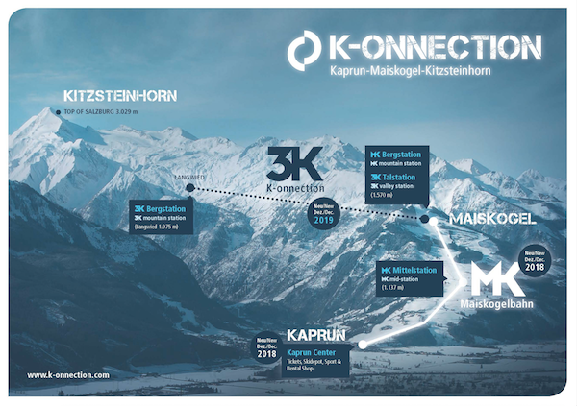 | The direct connection from the town of Kaprun /Maiskogel to the glacier: This ambitious project of Gletscherbahnen Kaprun AG will represent the longest continuous lift axis (12 km) spanning the greatest elevation change in the Eastern Alps.  Photo: Overview of the K-onnection @Gletscherbahnen Kaprun AG
The Kaprun Center is already rising out of the ground. As of December 2018, it will unite the valley station of the MK Maiskogelbahn, ticket windows, a sports & rental shop, the ski depot and the GBK corporate headquarters under one roof.
Photo: Gletscherbahnen Kaprun AG / Eva Reifmüller

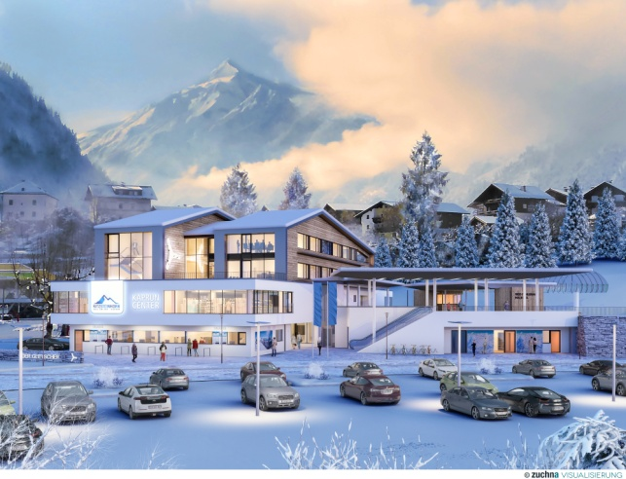 | The new Kaprun Center: This multifunction building brings together ticket windows, Intersport Bründl Maiskogel – a modern, spacious sporting goods and rental store, as well as a big ski depot under one roof.  Rendering: Kaprun Center  MAB Architektur Projektmanagement
The top terminal of the MK Maiskogelbahn is simultaneously the bottom station of the 3K K-onnection, the tri-cable gondola lift up the Kitzsteinhorn.

Rendering: K-onnection MK Berg/3K bottom station
MAB Architektur Projektmanagement
Photo credits: Photos may be duplicated free of charge if accompanied by accurate copyright citation.

