Press Information
Kaprun, February 2019

3K K-ONNECTION – The Connection to the Future
from Kaprun straight up to the Kitzsteinhorn as of winter 2019/20

Upon completion of the 3K K-onnection – the heart of a continuous link from the town center up to the Kitzsteinhorn – Kaprun’s generational project will become a reality. The initial construction stage concluded with the opening of the new MK Maiskogelbahn and the multifunction Kaprun Center in December 2018. The 3K K-ONNECTION – Salzburg’s very first tri-cable gondola system – will begin operating on 30 November 2019: Now boasting a direct link from the town center all the way up to the Kitzsteinhorn, as of winter 2019/20 Kaprun will be able to offer a ski-in-ski-out glacier experience, with snows that are 100% guaranteed, for the very first time. Not only will this superlative chain of lifts up to 3029 m above sea level bring whole new perspectives and opportunities to locals and guests, it will also strengthen Zell am See-Kaprun as a top tourism destination in the long term.

MK Maiskogelbahn – summer premier on Kaprun’s family mountain
In two sections, the new MK Maiskogelbahn links the town center of Kaprun via the Stanger mid-station to the Maiskogel mountain terminal. Already in this, its first season, winter sports fans are excited about this family-friendly, gentle and “weatherproof” addition to the Kitzsteinhorn glacier ski area. We can now look forward to a second premiere in summer 2019: Thanks to this new lift, even the hiking and biking paths on the Maiskogel will be accessible by cable car from the town center for the first time, between 25 May and 29 September 2019. The ever-popular Maisiflitzer Alpine Coaster, the Family Park right next to it and the Maisialm will all remain open year-round just as they did before.

3K K-ONNECTION – core of the Kaprun-Kitzsteinhorn connection opens on 30 November
In parallel to construction of the MK-Maiskogelbahn in 2018, the valley station and mountain terminal as well as the first support pylons for the 3K K-onnection were already being built as well. After the winter break, construction work to complete Salzburg’s first tri-cable gondola lift will recommence in spring 2019. The 4311 meters-long tri-cable lift promises complete comfort and unique panoramic views. With a total of 32 cabins each accommodating 32 people, guests will float gently up to the Langwied station at 1975 m in just 9 minutes. The opening of the 3K K-onnection on 30 November 2019 will clearly mark the beginning of a whole new era in Alpine tourism.

Ski-in-Ski-out and a superlative chain of gondolas
The 3K K-onnection is the core of the Kaprun – Maiskogel – Kitzsteinhorn connection. Thanks to this spectacular lift, as of winter 2019/20 this glacier community will be able to offer a ski-in-ski-out experience between the town center and the glacier ski area, where snow is 100% guaranteed, for the first time. The fact that the lifts and the ski area are within convenient walking distance of hotels or readily reachable by ski bus, along with the modern infrastructure at the Kaprun Center including a newest-generation ski depot and an Intersport Bründl sports shop, also guarantees added year-round quality and comfort. Six gondolas stretch out like a string of pearls from the town center, across four different vegetation zones, all the way up to the Top of Salzburg on the Kitzsteinhorn at 3029 m. Not only do they represent the longest uninterrupted lift axis in the Eastern Alps, they also cover the greatest elevation span (2261 vertical meters).

More information can be found at www.k-onnection.com and www.kitzsteinhorn.at

Kitzsteinhorn – The Glacier
The Kitzsteinhorn in the Zell am See-Kaprun region is actually the only glacier ski area in Salzburger Land. At 3000 m above sea level, winter sports fans can take full advantage of 100% reliable snow conditions from October until early summer. Thanks to the Maiskogel, Kaprun also boasts a second – family-friendly – ski area, that will now be connected directly to the glacier thanks to this generational project. In the first stage, the MK Maiskogelbahn, a 10-passenger gondola up the Maiskogel, went into service in December 2018. On 30 November 2019, the 3K K-onnection will go into operation. At that point, the first tri-cable gondola in Salzburg will carry guests from the Maiskogel straight up to the Langwied area on the Kitzsteinhorn. As a result, beginning in December 2019 it will be possible to reach the mountain terminal on the Kitzsteinhorn (TOP OF SALZBURG, elev. 3029 m) from Kaprun town center (768 m) by means of a string of pearls consisting of six lifts. The 12 km scenic lift ride will not only be the longest continuous lift axis in the Eastern Alps, it will also overcome the greatest elevation change (2261 vertical meters).

TECHNOLOGY: K-ONNECTION Facts

3K K-ONNECTION – Salzburg’s first tri-cable gondola lift
TECHNOLOGY
Lift system | 3S – tri-cable gondola lift  with 32 cabins for 32 people each, Doppelmayr/CWA
Capacity | 2,700 passengers/h at a max. speed of 8 m/s
Elevation | Valley station 1,570 m  Mountain terminal 1,975 m
Length | 4,311 m
Travel time | 9.1 min
SCHEDULE | Construction start 12 April 2018
 | Opening 30 November 2019
MK Maiskogelbahn
TECHNOLOGY
Lift system | Mono-cable gondola lift  with 123 cabins for 10 people each, Leitner ropeways
Capacity | 2,800 passengers/h at a max. speed of 6 m/s
Elevation | Valley station 768 m  Mid-station 1,137 m  Mountain terminal 1,570 m
Length | 3,813 m
Travel time | 12 min
SCHEDULE | Opened on 14 December 2018
Kaprun Center
Service Center | - Ticket windows & information  - Depot with up to 2,000 lockers  - Rental & sports shop,  Intersport Bründl Maiskogel
Company headquarters | Administration/offices of Gletscherbahnen Kaprun AG
SCHEDULE | Opened on 14 December 2018
Investment
- MK Maiskogelbahn  - Kaprun Center  - 3K Kaprun-Kitzsteinhorn-K-onnection | EUR 81.5 million

Photo materials
Downloadable at: https://www.kitzsteinhorn.at/en/service/backstage/press/3k-k-onnection---the-connection-to-the-future-pr4101

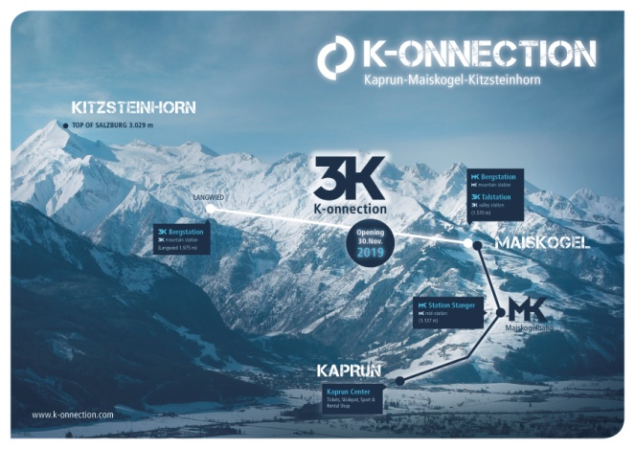 | A direct connection from the town of Kaprun/Maiskogel to the glacier: the ambitious project of Gletscherbahnen Kaprun AG. With a total length of 12 km, it will represent the longest continuous lift axis in the Eastern Alps, also covering the greatest elevation span.  Photo: Kitzsteinhorn
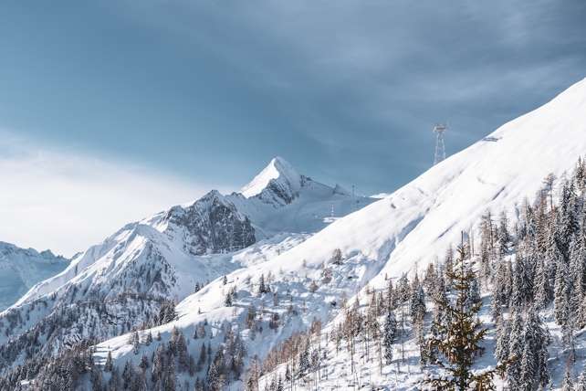 | In parallel to construction of the MK-Maiskogelbahn in 2018, the valley station and mountain terminal as well as the first support pylons for the 3K K-onnection were already being built as well. After the winter break, construction work to complete Salzburg’s first tri-cable gondola lift will recommence in spring 2019.  Photo: Kitzsteinhorn
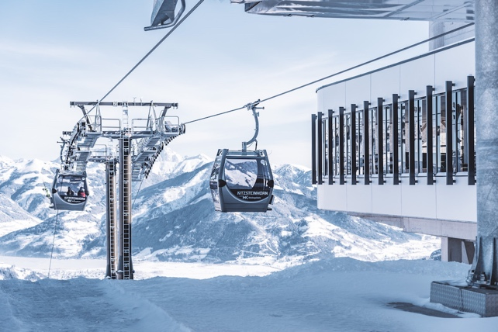 | The mountain terminal of the MK Maiskogelbahn also serves as the valley station of the 3K K-onnection – Salzburg’s first tri-cable gondola opens in November 2019.  Photo: Kitzsteinhorn
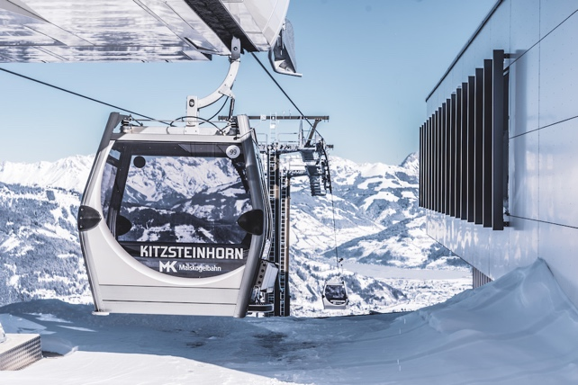 | The new MK Maiskogelbahn, a 10-passenger mono-cable gondola, provides a whole new quality of lift service to Kaprun’s family mountain.  Photo: Kitzsteinhorn
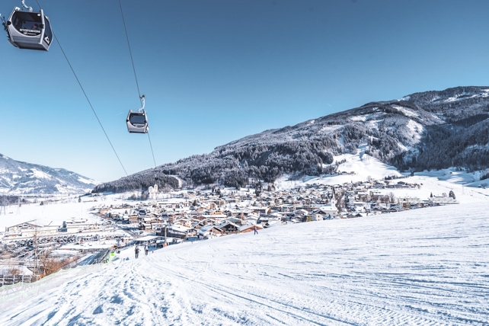 | The opening of the 3K K-onnection in November 2019 will create a lift connection from the Maiskogel to the Kitzsteinhorn. Marking the dawn of a whole new era in Kaprun: ski-in-ski-out with a 100% snow guarantee.  Photo: Kitzsteinhorn

Additional photo materials related to this project:
https://www.kitzsteinhorn.at/de/service/backstage/presse-k-onnection

Kitzsteinhorn photo materials
https://www.kitzsteinhorn.at/de/service/backstage/presse

Photo credits: Photos may be reprinted free of charge subject to citation of copyright.

