Press Information
Kaprun, May 2019

Kitzsteinhorn: 3K K-onnection – final construction phase begins
Direct connection as of winter 2019/20: between Kaprun town center and the glacier

With the winter break now over, final construction work on the new 3K K-onnection, Salzburg’s first tri-cable gondola from the Maiskogel to the Kitzsteinhorn, is now underway. The new cabins from renowned lift manufacturer Doppelmayr were presented to the world for the first time at the beginning of May during Interalpin 2019, the leading international trade expo for alpine technologies. The spectacular stringing of cables for the 4.3 km-long lift will happen in summer, as will delivery of the 32 custom-designed cabins. The 3K K-onnection will go into operation in November 2019, connecting what has always belonged together: The town center of Kaprun, Maiskogel family ski area and the Kitzsteinhorn glacier ski area will be united as one. For Kaprun, this represents the fulfillment of a generational dream. And the Zell am See-Kaprun region will embark on a whole new era of alpine tourism.

MK Maiskogelbahn - successful winter launch, now open in summer for the first time
The new MK Maiskogelbahn and Kaprun Center, the first stage of Kaprun’s generational project, definitely proved themselves up to the task in their first season. The 10-passenger mono-cable lift, which went into service in December 2018, offers both high-quality access to the popular family mountain and, thanks to the new Stanger mid-station, several completely new options as well. In the snowy winter of 2018/19, the Maiskogel – close to town, with gentle mountainsides at mid-alpine elevations – was an ideal complement to the high-alpine glacier ski area, making it yet another outstanding option for winter sports fans.
Yet another premiere will follow on May 25, 2019: With the help of the MK Maiskogelbahn, for the first time the hiking and biking paths on Kaprun’s local mountain will also be reachable by gondola directly from the center of town.

Final construction work for the 3K K-onnection has begun
In fact, construction of the 3K K-onnection actually began in 2018, parallel to work on the MK-Maiskogelbahn, with the building of the mountain and valley terminals as well as installation of pylons. In April 2019, work got back underway for completion of the 4311 meters-long 3K K-onnection. With the lift technology in place, the elaborate and quite spectacular procedure of stringing the cabling itself is scheduled for July. The cabins will be delivered and installed in August by CWA, a subsidiary of Doppelmayr. The grand opening of the new lift will be on November 30, at which point a long-held dream of Kaprun’s residents, a connection between the two ski areas on the Kitzsteinhorn and Maiskogel, will become reality.

Ski-in-Ski-out and a superlative chain of lifts
The custom-designed tri-cable gondola lift is being supplied by Austrian company Doppelmayr. The new, top-quality ATRIA cabins which are going to be used on the Kitzsteinhorn will be making their world debut. Aside from exceptionally comfortable ride characteristics, the 360° glass sides guarantee unique panoramic views.
The 3K K-onnection represents the heart and soul of the entire K-ONNECTION, serving as a link from the town center of Kaprun, via the Maiskogel to the TOP OF SALZBURG on the Kitzsteinhorn at 3029 m above sea level. Consisting of six consecutive lifts, not only will it represent the longest uninterrupted lift axis in the Eastern Alps, it will also span the greatest elevation – 2261 vertical meters – providing comfortable, convenient access to a whole new world for everyone. Now boasting ski-in-ski-out between the town center and the 100% snowy glacier, Kaprun will join the ranks of the elite Alpine ski areas. Until the actual lift opens on November 30, 2019, a fascinating animated video provides a first impression of the unique panoramic ride from Kaprun via the Maiskogel to the Kitzsteinhorn.

Link to the animated video: https://www.youtube.com/watch?v=wvReBaf84zk&feature=youtu.be

Further information can be found online at www.k-onnection.com and www.kitzsteinhorn.at

Kitzsteinhorn – the glacier
The Kitzsteinhorn in the Zell am See-Kaprun region is actually the only glacier ski area in Salzburger Land. At 3000 m above sea level, winter sports fans can take full advantage of 100% reliable snow conditions from October until early summer. Thanks to the Maiskogel, Kaprun also boasts a second – family-friendly – ski area, that will now be connected directly to the glacier thanks to this generational project. In the first stage, the MK Maiskogelbahn, a 10-passenger gondola up the Maiskogel, went into service in December 2018. On 30 November 2019, the 3K K-onnection will go into operation. At that point, the first tri-cable gondola in Salzburg will carry guests from the Maiskogel straight up to the Langwied area on the Kitzsteinhorn. As a result, beginning in December 2019 it will be possible to reach the mountain terminal on the Kitzsteinhorn (TOP OF SALZBURG, elev. 3029 m) from Kaprun town center (768 m) by means of a string of pearls consisting of six lifts. The 12 km scenic lift ride will not only be the longest continuous lift axis in the Eastern Alps, it will also overcome the greatest elevation change (2261 vertical meters).

TECHNOLOGY: K-ONNECTION Facts & Figures

3K Kaprun-Kitzsteinhorn K-onnection
TECHNOLOGY
Lift system | Tri-cable gondola  with 32 cabins for 32 people each,
Capacity | 2700 passengers/h at a max. speed of 8 m/s
Elevation | Valley station 1570 m  Mountain terminal 1975 m
Length | 4311 m
Travel time | 9.1 min
SCHEDULE | Construction start 12 April 2018
 | Opening 30 November 2019
MK Maiskogelbahn
TECHNOLOGY
Lift system | Mono-cable gondola lift  with 123 cabins for 10 people each,
Capacity | 2800 passengers/h at a max. speed of 6 m/s
Elevation | Valley station 768 m  Mid-station 1137 m  Mountain terminal 1570 m
Length | 3813 m
Travel time | 12 min
SCHEDULE | Construction start 12 April 2018
 | Opening 14 December 2018
Kaprun Center
Service Center | - Ticket windows & information  - Depot with up to 2,000 lockers  - Rental & sports shop,  Intersport Bründl Maiskogel
Company headquarters | Administration/offices of Gletscherbahnen Kaprun AG
SCHEDULE | Construction start Autumn 2017  Opening 14 December 2018
Investment
- MK Maiskogelbahn  - 3K Kaprun-Kitzsteinhorn-K-onnection  - Kaprun Center | EUR 81.5 million

Photo Materials
Downloadable at:
Link to the animated video: https://www.youtube.com/watch?v=wvReBaf84zk&feature=youtu.be

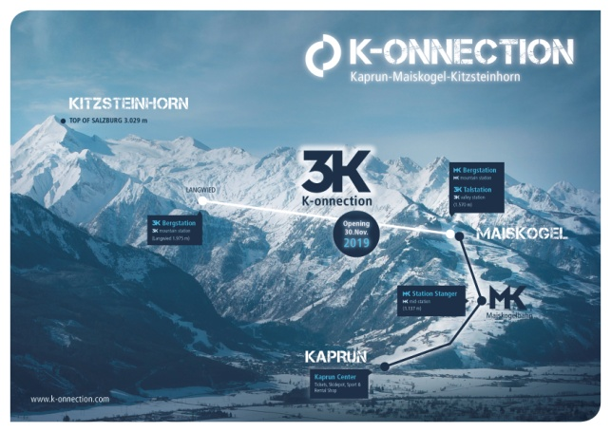 | A direct connection from the town of Kaprun/Maiskogel to the glacier: the ambitious project of Gletscherbahnen Kaprun AG. With a total length of 12 km, it will represent the longest continuous lift axis in the Eastern Alps, also covering the greatest elevation span.  Photo: Kitzsteinhorn
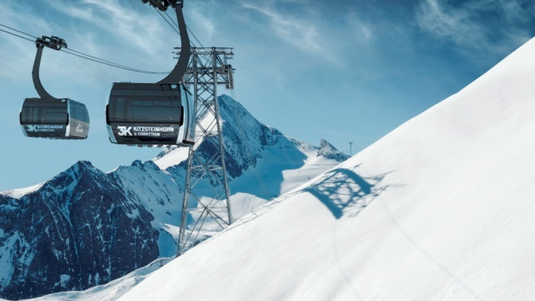 | A lift connection from the Maiskogel to the Kitzsteinhorn will become reality with the opening of the 3K K-onnection in November 2019. Salzburg’s first tri-cable gondola manufactured by Austrian company Doppelmayr is equipped with modern, custom-designed ATRIA cabins that will make their world premiere here on the Kitzsteinhorn.  Photo: Kitzsteinhorn/a still from the animated video

Additional photo materials related to this project:
https://www.kitzsteinhorn.at/de/service/backstage/presse-k-onnection

Kitzsteinhorn photo materials
https://www.kitzsteinhorn.at/de/service/backstage/presse

Photo credits: Photos may be reprinted free of charge subject to citation of copyright.

