Press Information
Kaprun, August 2019

KAPRUN – KITZSTEINHORN: connected as of 30 November!
The direct K-ONNECTION from Kaprun up to the glacier
On 30 November, the long-awaited dream of a connection between the town of Kaprun and the Kitzsteinhorn will come true. With the opening of the 3K K-onnection – Salzburg’s first tri-cable gondola and the heart of the K-ONNECTION – the Kaprun town center, Maiskogel Family Mountain and the 100% always-snowy glacier ski area on the Kitzsteinhorn will be transformed into a single unit. This guarantees ultimate convenience, offering ski-in-ski-out between Kaprun and the glacier for the first time along with a unique panoramic ride that treats passengers to fascinating perspectives.
K-ONNECTION - the superlative lift axis
The heart of the K-ONNECTION, the 3K K-onnection, promises a one-of-a-kind experience thanks to 32 cabins running on Salzburg’s very first tri-cable gondola lift. The 360° glass walls of the cabins reveal breathtaking panoramas of Salzachtal, Zeller See and the highest peaks in all of Austria. Six lift stages extend like a string of pearls from the town center to the TOP OF SALZBURG on the Kitzsteinhorn at 3029 m. Kaprun – Maiskogel - Kitzsteinhorn is a once-in-a-lifetime panoramic ride that covers a distance of 12 km, making it the longest continuous lift axis in the Eastern Alps, simultaneously spanning the greatest elevation change at 2261 m.
Ski-in-Ski-out from Kaprun town center
The K-ONNECTION offers guests in Kaprun a whole new holiday dimension in the form of ski-in-ski-out: Just imagine, now being able to set out from the town center of Kaprun – the ultimate in convenience, no car required – riding all the way up to the glacier, returning in the afternoon on skis and winding down your fantastic day of skiing with a full dose of après-ski. The Kaprun Center, which is also the valley station of the MK Maiskogelbahn, boasts a modern ski depot with up to 2000 storage lockers along with the spacious Bründl sports & rental shop, providing the ideal infrastructure for a marvelously enjoyable ski getaway.
100 % snow guarantee and highest piste quality
At the same time as the 3K K-onnection opens, the upgrades and expansion of snowmaking capability on the Maiskogel will also be completed, promising an early start to ski season on Kaprun’s popular family mountain as well as highest piste quality all winter long.
New: two lift gateways to the Kitzsteinhorn
The opening of the K-ONNECTION now means that, for the first time, guests have two different lift options for reaching the Kitzsteinhorn. Locals as well as guests living in town are within easy walking distance of the Kaprun Center and ski depot, able to begin their journey up to the Kitzsteinhorn by hopping aboard the MK Maiskogelbahn. Day visitors and those wishing to reach the glacier ski area direct will likely head for the valley station of the tried-and-true Glacier Jet lift.
Kitzsteinhorn EXPLORER TOUR
This winter for the very first time, National Park Rangers will accompany the popular Kitzsteinhorn Nature Explorer Tour from the center of town up to the glacial world of eternal ice at 3029 m. Every Tuesday, guests aboard two specially equipped Explorer Cabins can expect to be astonished as, led by an experienced National Park Ranger, they are able to immerse themselves completely in the fascinating world of the high Alps and the adjacent national park. Participants get to enjoy an eagle’s eye view, floating comfortably up through four vegetation zones as they rise 2261 vertical meters. Having reached the TOP OF SALZBURG at 3029 m, numerous experiences await: including Gipfelwelt 3000 with Cinema 3000 and the National Park Gallery, along with the highest restaurant in Salzburg province.
Ski ALPIN CARD: the new key to unlimited skiing enjoyment
As of winter 2019/20, the Ski ALPIN CARD is a new key to three premium ski regions: Skicircus Saalbach Hinterglemm Leogang Fieberbrunn, Schmittenhöhe in Zell am See as well as the glacier ski area of Kitzsteinhorn Kaprun. The Ski ALPIN CARD, which is available as a single- or multiple-day ticket, as a season or year-round lift pass, offers 408 piste kilometers, 121 lifts and countless attractions – including a snow guarantee on the glacier – for unlimited skiing enjoyment.
For initial impressions of this fascinatingly beautiful scenic ride, we invite you to view our video animation.
Video link: K-ONNECTION KAPRUN – MAISKOGEL – KITZSTEINHORN
https://www.youtube.com/watch?v=wvReBaf84zk&feature=youtu.be

Further information is available at www.k-onnection.com and www.kitzsteinhorn.at

Kitzsteinhorn – the glacier
The Kitzsteinhorn in the Zell am See-Kaprun region is actually the only glacier ski area in Salzburger Land. At 3000 m above sea level, winter sports fans can take full advantage of 100% reliable snow conditions from October until early summer. Thanks to the Maiskogel, Kaprun also boasts a second – family-friendly – ski area, that will now be connected directly to the glacier thanks to this generational project. In the first stage, the MK Maiskogelbahn, a 10-passenger gondola up the Maiskogel, went into service in December 2018. On 30 November 2019, the 3K K-onnection will go into operation. At that point, the first tri-cable gondola in Salzburg will carry guests from the Maiskogel straight up to the Langwied area on the Kitzsteinhorn. As a result, beginning in December 2019 it will be possible to reach the mountain terminal on the Kitzsteinhorn (TOP OF SALZBURG, elev. 3029 m) from Kaprun town center (768 m) by means of a string of pearls consisting of six lifts. The 12 km scenic lift ride will not only be the longest continuous lift axis in the Eastern Alps, it will also overcome the greatest elevation change (2261 vertical meters). Beginning in winter 2019/20, the Kitzsteinhorn will also be part of the ALPIN CARD ticket alliance. The new Ski ALPIN CARD, which is available as a single- or multiple-day ticket, as a season or year-round lift pass, offers 408 piste kilometers, 121 lifts and countless attractions – including a snow guarantee on the glacier – for unlimited mountain enjoyment.

TECHNOLOGY: K-ONNECTION Facts & Figures

3K Kaprun-Kitzsteinhorn K-onnection
TECHNOLOGY
Lift system | Tri-cable gondola  with 32 cabins for 32 people each,
Capacity | 2700 passengers/h at a max. speed of 8 m/s
Elevation | Valley station 1570 m  Mountain terminal 1975 m
Length | 4311 m
Travel time | 9.1 min
SCHEDULE | Construction start 12 April 2018
 | Opening 30 November 2019
MK Maiskogelbahn
TECHNOLOGY
Lift system | Mono-cable gondola lift  with 123 cabins for 10 people each,
Capacity | 2800 passengers/h at a max. speed of 6 m/s
Elevation | Valley station 768 m  Mid-station 1137 m  Mountain terminal 1570 m
Length | 3813 m
Travel time | 12 min
SCHEDULE | Construction start 12 April 2018
 | Opening 14 December 2018
Kaprun Center
Service Center | - Ticket windows & information  - Depot with up to 2,000 lockers  - Rental & sports shop,  Intersport Bründl Maiskogel
Company headquarters | Administration/offices of Gletscherbahnen Kaprun AG
SCHEDULE | Construction start Autumn 2017  Opening 14 December 2018
Investment
- MK Maiskogelbahn  - 3K Kaprun-Kitzsteinhorn-K-onnection  - Kaprun Center | EUR 81.5 million

Photo Materials
Downloadable at: https://www.kitzsteinhorn.at/de/service/backstage/presse/3k-k-onnection---finale-bauphase-gestartet-pr4507
Link to the video animation: K-ONNECTION KAPRUN – MAISKOGEL – KITZSTEINHORN
https://www.youtube.com/watch?v=wvReBaf84zk&feature=youtu.be

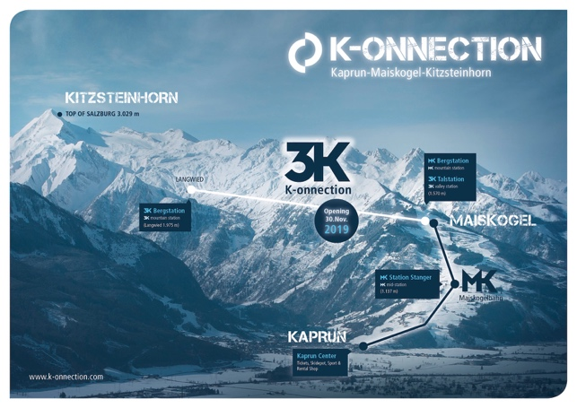 | A direct connection from the town of Kaprun/Maiskogel to the glacier: the ambitious project of Gletscherbahnen Kaprun AG. With a total length of 12 km, it will represent the longest continuous lift axis in the Eastern Alps, also covering the greatest elevation span.  Photo: ©Kitzsteinhorn
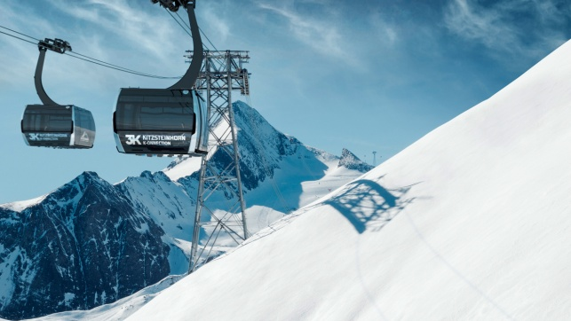 | With the opening of the 3K K-onnection, Salzburg’s first tri-cable gondola, a connection from the Maiskogel to the Kitzsteinhorn will become reality in November 2019.  Photo: 3K K-onnection/picture from the video animation  @Kitzsteinhorn
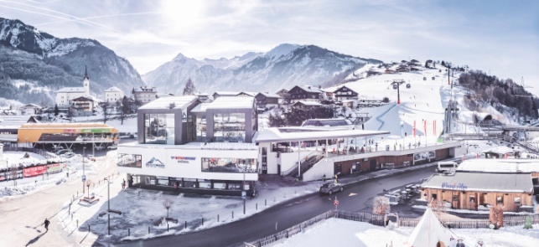 | The K-ONNECTION Kaprun – Maiskogel – Kitzsteinhorn sets out from the Kaprun Center, a multi-function service center home to the valley station of the MK Maiskogelbahn, a modern ski depot with up to 2000 lockers, and a Bründl Sports shop.  Photo: Kaprun Center - gateway to the K-ONNECTION  ©Kitzsteinhorn
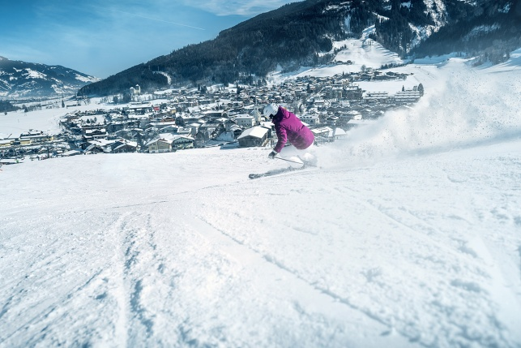 | Ski-in-Ski-out directly to and from the glacier – the  K-ONNECTION Kaprun – Maiskogel – Kitzsteinhorn opens a whole new dimension of winter sport for Kaprun.  Photo: From the 100 % snow-covered Kitzsteinhorn glacier ski area, via Maiskogel Family Mountain directly to the town center of Kaprun  Photo: From the glacier directly to the town center of Kaprun  © Kitzsteinhorn

Additional photo materials related to this project:
https://www.kitzsteinhorn.at/de/service/backstage/presse-k-onnection

Kitzsteinhorn photo materials
https://www.kitzsteinhorn.at/de/service/backstage/presse

Photo credits: Photos may be reprinted free of charge subject to citation of copyright.

