Press Information
K-ONNECTED: Kaprun – Maiskogel – Kitzsteinhorn
directly from Kaprun up to the glacier

Generations have dreamed of creating a lift connection between Kaprun, the Maiskogel and the Kitzsteinhorn. And since 30 November 2019, that dream has become reality: With the opening of the 3K K-onnection, Salzburg’s first tri-cable gondola and heart of the
K-ONNECTION, the town center of Kaprun, Maiskogel Family Mountain and the always-snowy glacier ski area on the Kitzsteinhorn are now united as one. Guaranteeing unlimited skiing enjoyment for the whole family along with the ultimate convenience technology can provide. As a consequence, Kaprun now offers ski-in-ski-out to and from the glacier for the very first time. The newly created 12 km long lift axis is unsurpassed, revealing one-of-a-kind panoramic views and spanning the greatest elevation change in the Eastern Alps at 2261 meters.

Bringing together what belongs together
The desire to link both of Kaprun’s ski areas by lift has been around for generations. On 30 November 2019, the new 3K K-onnection was opened, finally bringing together what belongs together. The town center of Kaprun, the Maiskogel family ski area and Kitzsteinhorn glacier ski area have now been united to create a single entity, with direct access to the glacier from the heart of town. This marks the fulfillment of a long-held dream here in Kaprun. The new K-ONNECTION lift link is the second monumental step in the history of Kaprun following the development of the first glacier ski area on the Kitzsteinhorn back in 1965. Realization of this generational project heralds the beginning of a new era in alpine tourism for the Zell am See – Kaprun region: When it comes to scenery, reliable snow conditions, service quality and accessibility due to outstanding infrastructure, no mountain in the Eastern Alps can compare with the Kitzsteinhorn.

New 3K K-onnection: an extraordinary panoramic ride
The 4.3 km long 3K K-onnection, Salzburg’s first tri-cable gondola, offers a ride-experience of extraordinary quality in 32 latest-generation cabins. The world premiere of the new ATRIA panorama cabins from Swiss company CWA also represents a design highlight. The comfortably equipped, totally glass-sided cabins treat guests to breathtaking panoramic views of the Salzach River Valley, Lake Zeller See and the highest peaks in all of Austria. As many as six lift stages extend like a string of pearls from the town center of Kaprun up to the TOP OF SALZBURG on the Kitzsteinhorn at 3029 m. Traveling a total distance of 12 km, the one-of-a-kind panoramic journey Kaprun - Maiskogel - Kitzsteinhorn is actually the longest uninterrupted cableway, spanning the biggest elevation change (2261 m) in the Eastern Alps.

Kaprun offers ski-in-ski-out from the town center for the first time
In December 2018, the MK Maiskogelbahn and the Kaprun Center were opened, representing completion of the first high-quality stage of what would become the full K-ONNECTION Kaprun - Maiskogel - Kitzsteinhorn. Maiskogel Family Mountain, with its gentle slopes, is the perfect complement to the high-alpine glacier. As of winter season 2019/20, the K-ONNECTION offers guests in Kaprun ski-in-ski-out convenience to and from the glacier: Kaprun Center and thus the MK Maiskogelbahn are easy to reach on foot from downtown. At Kaprun Center, guests are able to take advantage of a modern ski depot with up to 2000 storage lockers along with a spacious Bründl Sports sporting goods and rental store – providing optimal infrastructure for total skiing enjoyment.
In parallel to the K-ONNECTION, expansion of snowmaking capability on the Maiskogel was also completed, guaranteeing an early start to ski season as well as highest piste-quality all winter long. Day visitors as well as those wishing to ride straight up to the glacier ski area will likely continue to select the lift they have been accustomed to, the Gletscherjet, whose valley station is located just 6 km outside of town.

Kitzsteinhorn EXPLORER TOUR: pure nature experience with National Park Rangers
The Kitzsteinhorn Explorer Tour is new as of December 2019, offering a wintry journey of discovery by means of the spectacular K-ONNECTION from Kaprun town center up into the realm of eternal glacier ice on the Kitzsteinhorn at 3029 m. In two specially equipped Explorer Cabins, National Park Rangers accompany nature-lovers every Tuesday in winter on a two-hour tour through four climate zones, sharing fascinating insights into the imposing mountain world, the natural phenomena of wintertime and the fascinating high-alpine world inside neighboring Hohe Tauern National Park. Having finally arrived at TOP OF SALZBURG, numerous other experiences are waiting to be enjoyed: including Gipfelwelt 3000 and Cinema 3000, the National Park Gallery and refreshments inside the highest restaurant in Salzburg.

Cautious handling of natural resources
The generational dream of creating a lift connection between Kaprun’s two ski mountains had existed for decades. After many years spent exploring different options, a decision was made in favor of this particular project, a project that is committed to utmost nature- and environmental conservation. The K-ONNECTION doesn’t involve creating new pistes and it significantly reduces the flow of private vehicles in the Kaprun valley. Due to an optimized drive concept and a tri-cable system, the energy consumption of the new 3K K-onnection is around 25% lower compared to other lift systems with a similar passenger capacity. Like all existing gondolas, ski lifts and buildings on the Kitzsteinhorn, the new 3K K-onnection is powered by CO₂-neutral, 100% eco-friendly electricity. With photovoltaic systems at Kaprun Center as well as at the mountain and valley stations of the new 3K K-onnection, 50,000 kWh are generated annually. When combined with the pumping station and small power plant which went into operation in 2011/12, that number rises to 1 million kWh per year. Energy-recovery of heat produced by the high-performance motors of the big lifts as well as the kitchens results in annual savings of 200,000 kWh. At Kaprun Center, featuring an innovative overall concept that qualifies the building as a Class A low-energy structure, a further 180,000 kWh of valuable energy resources are saved every single year. Gletscherbahnen Kaprun AG holds triple ISO certification for its quality-, environmental and energy management practices.

Ski ALPIN CARD: the new key to endless skiing enjoyment
The Ski ALPIN CARD is definitely the ticket highlight of Alpine Winter 2019/20. The same motto applies here: Get connected. It brings together the three premium ski regions Skicircus Saalbach Hinterglemm Leogang Fieberbrunn, Schmittenhöhe in Zell am See as well as the Kitzsteinhorn Kaprun glacier ski area to create a unique world of wintry adventures. The Ski ALPIN CARD, which is available as a one- or multi-day ticket as well as a season or year-round pass, promises extraordinary skiing experiences encompassing a total of 408 piste kilometers, 121 lifts and countless attractions – including guaranteed snow on the glacier itself. Especially for families and beginning skiers, Maiskogel Family Mountain will continue to offer affordable day tickets.

Kitzsteinhorn – the glacier
The Kitzsteinhorn in the Zell am See-Kaprun region is actually the only glacier ski area in Salzburger Land. At 3000 m above sea level, winter sports fans can take full advantage of 100% reliable snow conditions from October until early summer. Thanks to the Maiskogel, Kaprun also boasts a second – family-friendly – ski area, that will now be connected as of the end of November 2019 directly to the glacier. In the first stage, the MK Maiskogelbahn, a 10-passenger gondola up the Maiskogel, went into service in December 2018. On 30 November 2019, the 3K K-onnection will go into operation. At that point, the first tri-cable gondola in Salzburg will carry guests from the Maiskogel straight up to the Langwied area on the Kitzsteinhorn. As a result, beginning in December 2019 it will be possible to reach the mountain terminal on the Kitzsteinhorn (TOP OF SALZBURG, elev. 3029 m) from Kaprun town center (768 m) by means of a string of pearls consisting of six lifts. The 12 km scenic lift ride will not only be the longest continuous lift axis in the Eastern Alps, it will also overcome the greatest elevation change (2261 vertical meters). Beginning in winter 2019/20, the Kitzsteinhorn will also be part of the ALPIN CARD ticket alliance covering three premium regions: Skicircus Saalbach Hinterglemm Leogang Fieberbrunn, Schmittenhöhe in Zell am See and Kitzsteinhorn Kaprun. The Ski ALPIN CARD, which is available as a one- or multi-day ticket as well as a season or year-round pass, promises extraordinary skiing experiences encompassing a total of 408 piste kilometers, 121 lifts and countless attractions – with guaranteed snow on the glacier itself.
FACTS & FIGURES
K-ONNECTION Kaprun – Maiskogel - Kitzsteinhorn

3K K-onnection – Salzburg’s first tri-cable gondola
Elevations | Valley 1570 m I Mountain 1975 m
Lift System | Tri-cable gondola  Manufacturer: Doppelmayr Seilbahnen GmbH, Wolfurt/Austria  - Length: 4311 m  - Ride time: 9.0 min  - Capacity: 2700 passengers /h, maximum speed 8m/s  - 1 draw cable: diameter 46 mm, 216 individual wire strands;  track gauge 11-13 m  - 4 support cables: diameter 56 mm, 143 individual wire strands  - Cable weight: ca. 500 t in total  - 5 pylons: maximum height 92 m, longest span 2100 m  - Control concept: Connect  - Drive concept  _ 2 drive units, operation possible with just one  _ 2 emergency generators for the main drive  _ 1 electro-hydraulic emergency drive  _ second independent diesel-hydraulic emergency drive  _ ground rescue unnecessary, in the event of breakdowns cabins return to stations
Cabins | ATRIA cabins – used on the 3K K-onnection for the first time worldwide  Manufacturer: CWA Constructions SA/Corp. – Olten/Switzerland  30 cabins, 32 passengers each - seating for 24, standing room for 8  2 Explorer Cabins – seating for 15  1 maintenance cabin  - All cabins: fully glass-sided, electrically operated doors, intercom system  - Wi-Fi from start to finish including all stations  Kitzsteinhorn EXPLORER Cabins  2 special cabins with design and equipment features for exceptionally scenic rides
Construction Schedule | Construction start: 12 April 2018 I Opening: 30 November 2019

MK Maiskogelbahn – 10-passenger mono-cable gondola
Elevations | Valley 768 m I “Stanger” mid-station 1137 m I Mountain 1570 m
Lift System | 10-passenger mono-cable gondola lift  Manufacturer: Leitner AG, Sterzing/Italy  - Length: 3813 m  - Ride time: 12 min  - Capacity: 2800 passengers/ h, maximum speed 6 m/s
Cabins | 123 cabins, 10 passengers each
Construction Schedule | Construction start: autumn 2017 I Opened: 14 December 2018
Kaprun Center – Service Center and Corporate Headquarters
Service Center | - Ticket windows & information  - Depot with up to 2000 storage spaces  - Bründl Sports rental & sports shop
Corporate Headquarters | Executive/corporate offices of Gletscherbahnen Kaprun AG
Construction Schedule | Construction start: autumn 2017 I Opened: 14 December 2018

Project and Construction Management
Structural | Planning and construction management:  MAB Architektur & Projektmanagement, Kaprun
Ecological Consultation | Ecology Institute, Salzburg

Investment K-ONNECTION Kaprun – Maiskogel - Kitzsteinhorn
- MK Maiskogelbahn  - 3K K-onnection  - Kaprun Center | EURO 81.5 million

Photo Materials
Downloadable at: https://www.kitzsteinhorn.at/en/service/backstage/press-k-onnection
Link to the video animation: K-ONNECTION KAPRUN – MAISKOGEL – KITZSTEINHORN

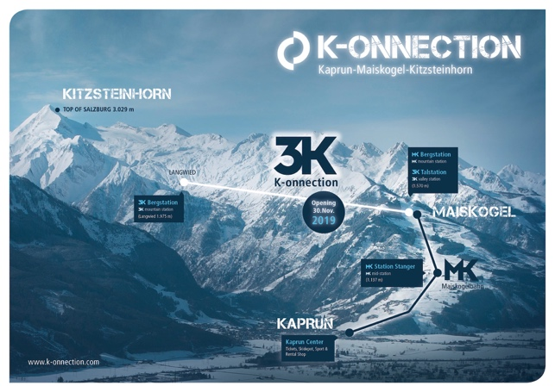 | The direct connection from the town of Kaprun over the Maiskogel to the glacier: As of winter season 2019/20, the new K-ONNECTION brings together what belongs together.  Photo: Visualization of the K-ONNECTION  ©Kitzsteinhorn
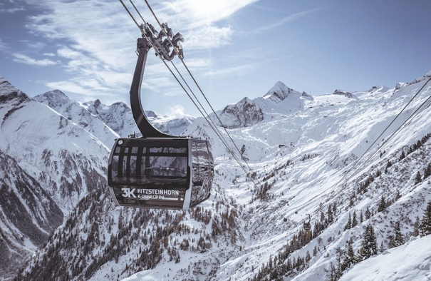 | On 30 November 2019, the 3K K-onnection goes into operation and will connect the Maiskogel with the Langwied area on the Kitzsteinhorn. With the opening of the new 3K K-onnection, Salzburg’s first tri-cable gondola, the Kaprun - Maiskogel - Kitzsteinhorn link will finally be completed. The 32 ATRIA panorama cabins by CWA offer passengers an extraordinary ride.  Photo: Panorama cabin on the 3K K-onnection  ©Kitzsteinhorn
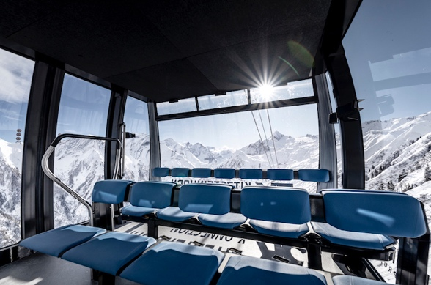 | The 32 ATRIA panorama cabins by CWA offer passengers an extraordinary ride.  Photo: Panorama cabin on the 3K K-onnection  ©Kitzsteinhorn
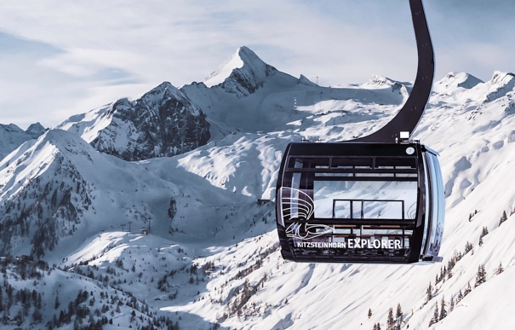 | Kitzsteinhorn EXPLORER TOUR: In two specially equipped Explorer Cabins, as of December 2019 National Park Rangers will accompany nature lovers on a wintry expedition through four climate zones up to the world of eternal ice on Kitzsteinhorn glacier (3029 m).  Photo: Explorer Cabin with 360° panoramic views  ©Kitzsteinhorn
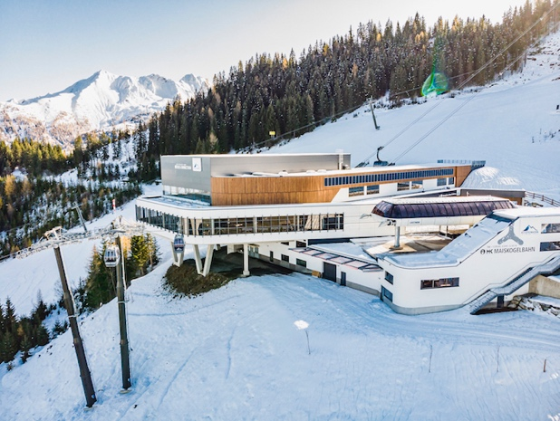 | Station on the Maiskogel at 1570 m: The mountain terminal of the MK Maiskogelbahn doubles as the valley station of the new 3K K-onnection.  Photo: Maiskogel mountain terminal  ©Kitzsteinhorn
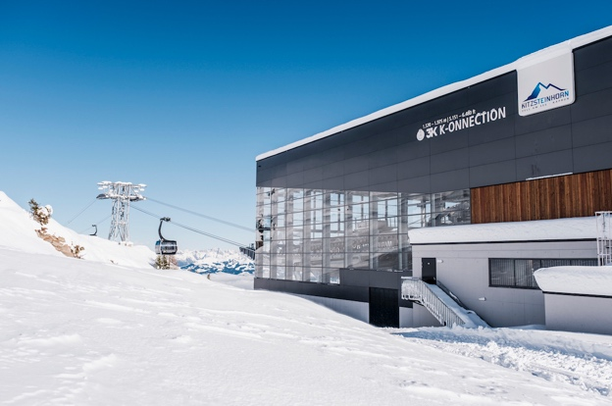 | The 3K K-onnection carries guests from the Maiskogel quickly and comfortably up to the Langwied area (1975 m) on the Kitzsteinhorn.  Photo: 3K-Konnection mountain terminal  ©Kitzsteinhorn
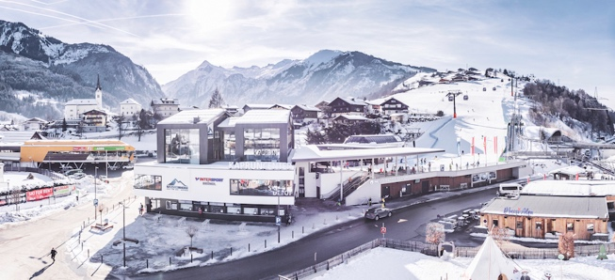 | The multi-function Kaprun Center, which was opened in December 2018, brings together under one roof the valley station of the MK Maiskogelbahn, ticket windows, Gletscherbahnen Kaprun AG corporate headquarters, a modern ski depot with storage for as many as 2000 sets of equipment, along with a spacious Bründl Sports sporting goods and rental store.  Bild: Kaprun Center  ©Kitzsteinhorn
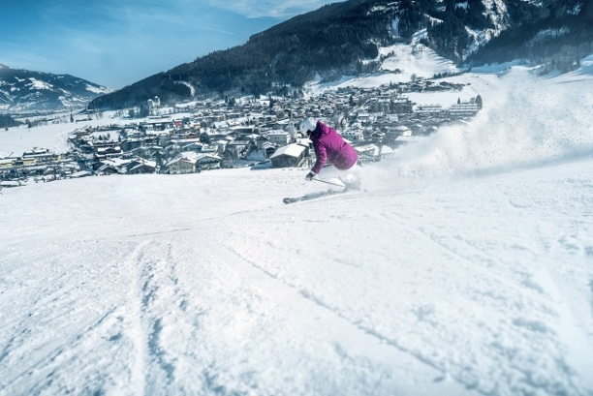 | Ski-in-ski-out directly to and from the glacier: The  K-ONNECTION Kaprun – Maiskogel – Kitzsteinhorn opens a whole new dimension of winter sport for Kaprun. Directly from the town center of Kaprun over Maiskogel Family Mountain up into the 100% snowy Kitzsteinhorn glacier ski area.  Photo: From the glacier directly to the town center of Kaprun  ©Kitzsteinhorn
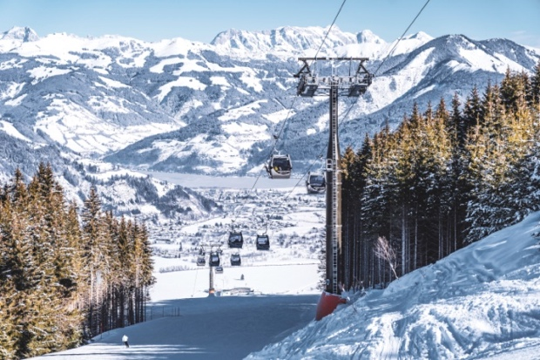 | With the MK Maiskogelbahn, the first stage of K-ONNECTION Kaprun – Maiskogel – Kitzsteinhorn was opened in December 2018. The 10-passenger single-cable gondola provides outstanding access to the family mountain just outside of town.  Photo: MK Maiskogelbahn with views of Kaprun and Zeller See  ©Kitzsteinhorn
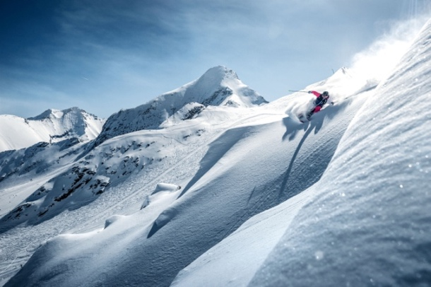 | Kitzsteinhorn: Salzburg’s only glacier ski area offers a 100% snow guarantee from October to June along with an unbeatable variety of winter sports, including broad glacier pistes, five freeride routes, four snowparks, a super pipe, Black Mamba pistes, the ICE CAMP presented by Audi and much more.  Photo: Freedom at 3000 m  ©Kitzsteinhorn
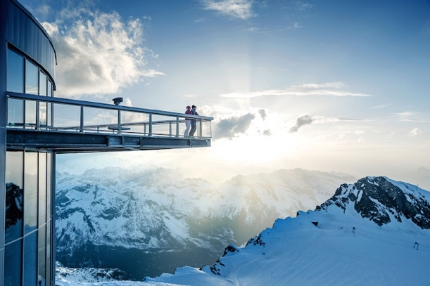 | Kitzsteinhorn TOP OF SALZBURG 3029 m: Salzburg’s highest viewing platform and 365-day nature and panorama experience right on the border of Hohe Tauern National Park.  Photo: TOP OF SALZBURG 3029 m  ©Kitzsteinhorn
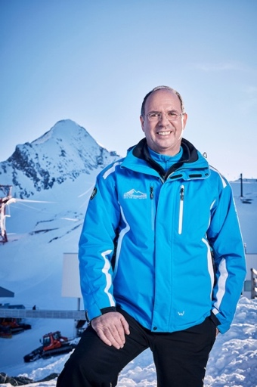 | Ing. Norbert, Karlsböck, Managing Director of Gletscherbahnen Kaprun AG  Photo: Ing. Norbert, Karlsböck, Managing Director  ©Kitzsteinhorn

Link: Press photographs of the Kitzsteinhorn

Photo credits: May be reprinted free of charge subject to citation of the copyright holder.

Press Contact:
Maria Hofer  Marketing Manager  Kitzsteinhorn - Gletscherbahnen Kaprun AG  Kitzsteinhornplatz 1a  A-5710 Kaprun  Tel.: +43 / (0) 6547 / 8700-171  Mobile: +43 / (0) 664 / 78 29 855  E-Mail: maria.hofer@kitzsteinhorn.at | Mag. Ursula Wirth  Mag. Ursula Maier  plenos – Agentur für Kommunikation  Paracelsusstraße 4  A-5020 Salzburg  Tel.: +43 / (0) 662 / 620242-14  Mobile.: +43 / (0) 676 / 83 786 213  E-Mail: ursula.maier@plenos.at

